1.Open MySql work bench and do as per below screen.

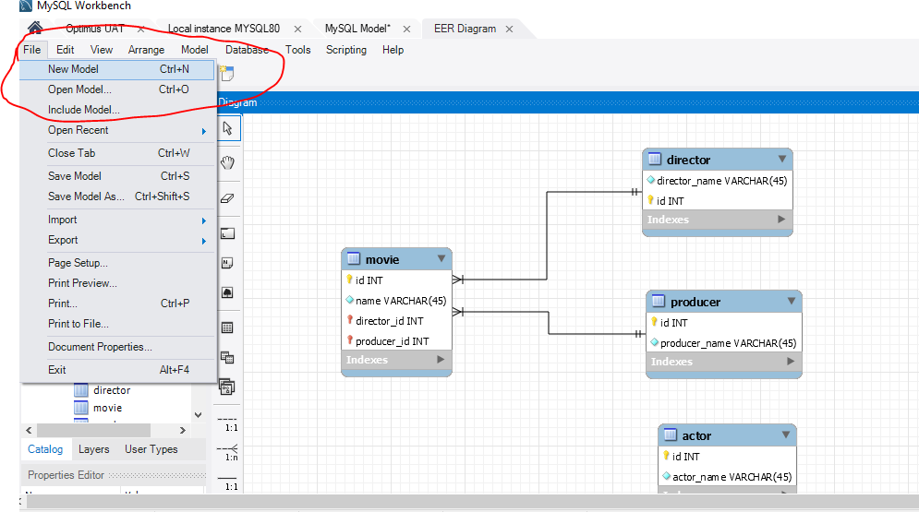

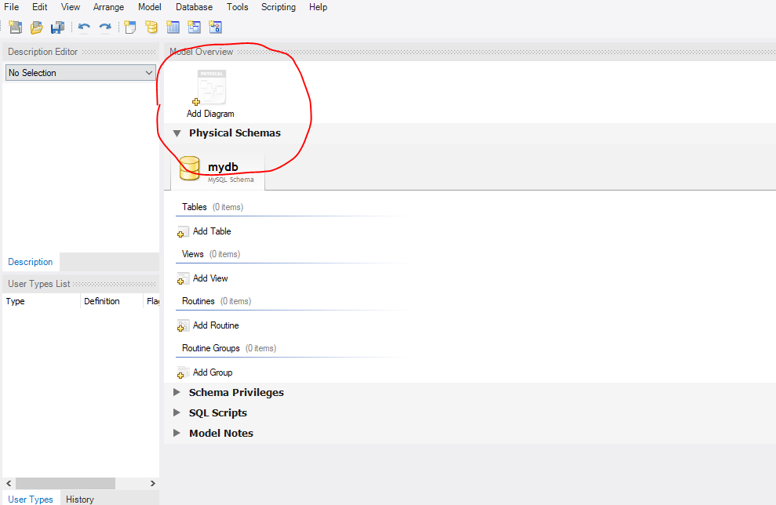

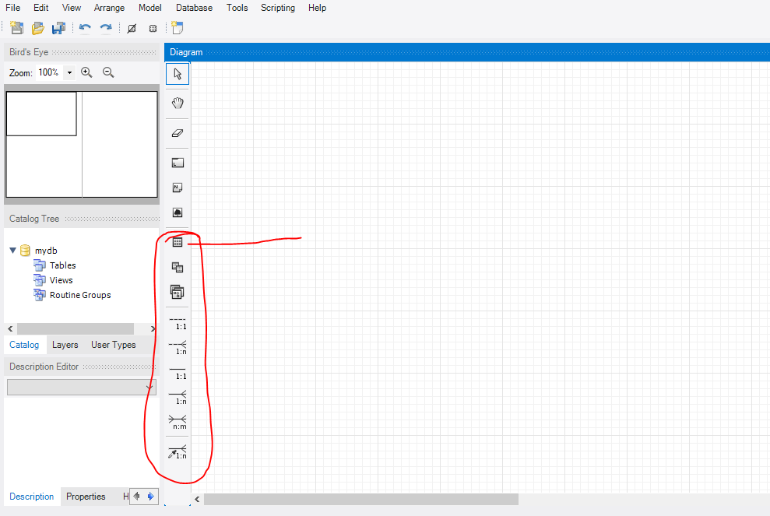

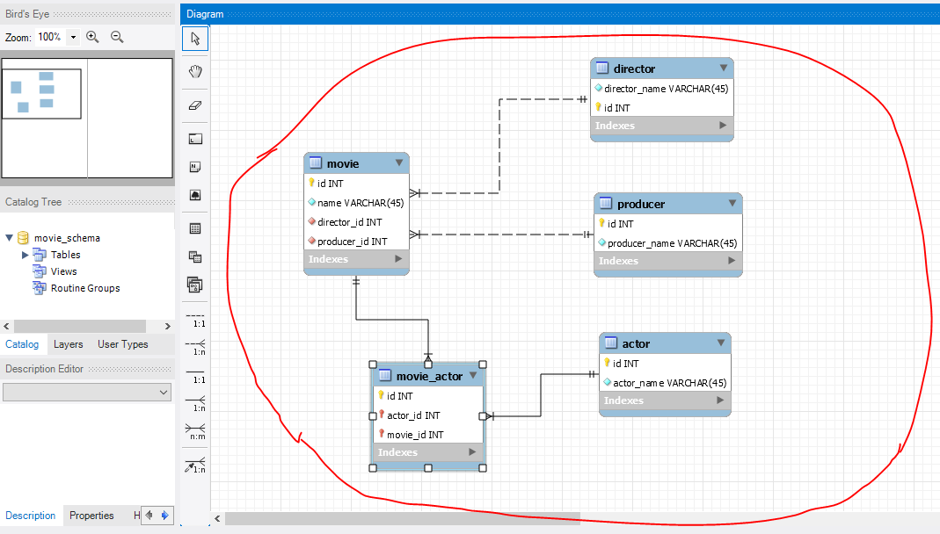

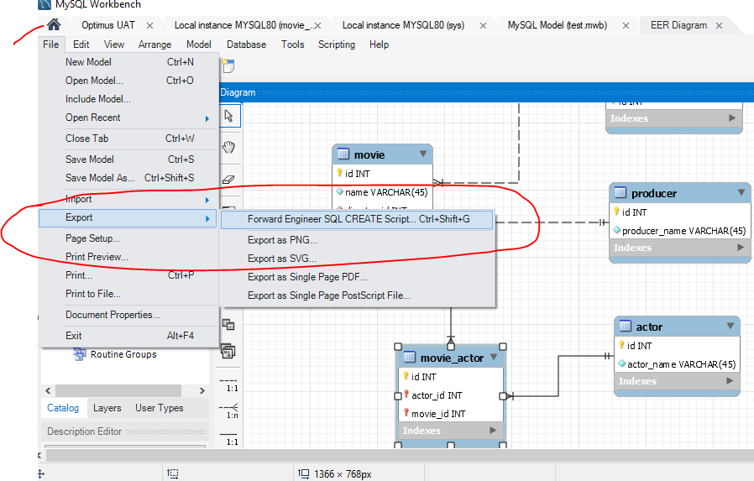

Above screen shot will do export the sql file to your local drive.

To test Run below query:

select m.name as movie_name,GROUP_CONCAT(a.actor_name SEPARATOR ', ') as actor_name ,d.director_name ,p.producer_name from director d ,producer p ,movie m inner join movie_actor ma

on m.id=ma.movie_id inner join actor a on ma.actor_id=a.id where m.director_id=d.id and m.producer_id=p.id

**Generated SQL DDL statements:**

**-- MySQL Script generated by MySQL Workbench**

**-- Wed Apr 24 15:20:00 2019**

**-- Model: New Model Version: 1.0**

**-- MySQL Workbench Forward Engineering**

**SET @OLD_UNIQUE_CHECKS=@@UNIQUE_CHECKS, UNIQUE_CHECKS=0;**

**SET @OLD_FOREIGN_KEY_CHECKS=@@FOREIGN_KEY_CHECKS, FOREIGN_KEY_CHECKS=0;**

**SET @OLD_SQL_MODE=@@SQL_MODE, SQL_MODE='TRADITIONAL,ALLOW_INVALID_DATES';**

**-- -----------------------------------------------------**

**-- Schema movie_schema**

**-- -----------------------------------------------------**

**-- -----------------------------------------------------**

**-- Schema movie_schema**

**-- -----------------------------------------------------**

**CREATE SCHEMA IF NOT EXISTS `movie_schema` DEFAULT CHARACTER SET utf8 ;**

**USE `movie_schema` ;**

**-- -----------------------------------------------------**

**-- Table `movie_schema`.`director`**

**-- -----------------------------------------------------**

**DROP TABLE IF EXISTS `movie_schema`.`director` ;**

**CREATE TABLE IF NOT EXISTS `movie_schema`.`director` (**

**`director_name` VARCHAR(45) NOT NULL,**

**`id` INT NOT NULL AUTO_INCREMENT,**

**PRIMARY KEY (`id`))**

**ENGINE = InnoDB;**

**-- -----------------------------------------------------**

**-- Table `movie_schema`.`producer`**

**-- -----------------------------------------------------**

**DROP TABLE IF EXISTS `movie_schema`.`producer` ;**

**CREATE TABLE IF NOT EXISTS `movie_schema`.`producer` (**

**`id` INT NOT NULL AUTO_INCREMENT,**

**`producer_name` VARCHAR(45) NOT NULL,**

**PRIMARY KEY (`id`))**

**ENGINE = InnoDB;**

**-- -----------------------------------------------------**

**-- Table `movie_schema`.`movie`**

**-- -----------------------------------------------------**

**DROP TABLE IF EXISTS `movie_schema`.`movie` ;**

**CREATE TABLE IF NOT EXISTS `movie_schema`.`movie` (**

**`id` INT NOT NULL AUTO_INCREMENT,**

**`name` VARCHAR(45) NOT NULL,**

**`director_id` INT NOT NULL,**

**`producer_id` INT NOT NULL,**

**PRIMARY KEY (`id`),**

**UNIQUE INDEX `id_UNIQUE` (`id` ASC),**

**INDEX `fk_movie_director1_idx` (`director_id` ASC),**

**INDEX `fk_movie_producer1_idx` (`producer_id` ASC),**

**CONSTRAINT `fk_movie_director1`**

**FOREIGN KEY (`director_id`)**

**REFERENCES `movie_schema`.`director` (`id`)**

**ON DELETE NO ACTION**

**ON UPDATE NO ACTION,**

**CONSTRAINT `fk_movie_producer1`**

**FOREIGN KEY (`producer_id`)**

**REFERENCES `movie_schema`.`producer` (`id`)**

**ON DELETE NO ACTION**

**ON UPDATE NO ACTION)**

**ENGINE = InnoDB;**

**-- -----------------------------------------------------**

**-- Table `movie_schema`.`actor`**

**-- -----------------------------------------------------**

**DROP TABLE IF EXISTS `movie_schema`.`actor` ;**

**CREATE TABLE IF NOT EXISTS `movie_schema`.`actor` (**

**`id` INT NOT NULL AUTO_INCREMENT,**

**`actor_name` VARCHAR(45) NOT NULL,**

**PRIMARY KEY (`id`))**

**ENGINE = InnoDB;**

**-- -----------------------------------------------------**

**-- Table `movie_schema`.`movie_actor`**

**-- -----------------------------------------------------**

**DROP TABLE IF EXISTS `movie_schema`.`movie_actor` ;**

**CREATE TABLE IF NOT EXISTS `movie_schema`.`movie_actor` (**

**`id` INT NOT NULL AUTO_INCREMENT,**

**`actor_id` INT NOT NULL,**

**`movie_id` INT NOT NULL,**

**PRIMARY KEY (`id`, `actor_id`, `movie_id`),**

**INDEX `fk_movie_actor_actor1_idx` (`actor_id` ASC),**

**INDEX `fk_movie_actor_movie1_idx` (`movie_id` ASC),**

**CONSTRAINT `fk_movie_actor_actor1`**

**FOREIGN KEY (`actor_id`)**

**REFERENCES `movie_schema`.`actor` (`id`)**

**ON DELETE NO ACTION**

**ON UPDATE NO ACTION,**

**CONSTRAINT `fk_movie_actor_movie1`**

**FOREIGN KEY (`movie_id`)**

**REFERENCES `movie_schema`.`movie` (`id`)**

**ON DELETE NO ACTION**

**ON UPDATE NO ACTION)**

**ENGINE = InnoDB;**

**SET SQL_MODE=@OLD_SQL_MODE;**

**SET FOREIGN_KEY_CHECKS=@OLD_FOREIGN_KEY_CHECKS;**

**SET UNIQUE_CHECKS=@OLD_UNIQUE_CHECKS;**